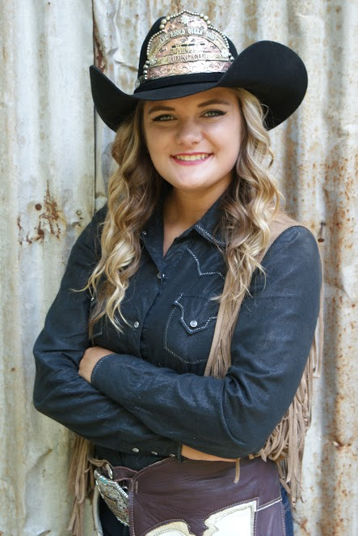

Hey Y’all! My name is Loran Lopez. I am the 21 year old daughter of Billye and Michael Hesson from Booneville, Arkansas. I am the reigning 2016 Lincoln Riding Club Rodeo Queen. Throughout my journey as Miss LRC, I have had some great sponsors and an even greater support system! I want to thank JJ’s Grill for sponsoring me and working around my crazy schedule. I would also like to thank my wonderful grandparents who haul me all across the state whenever I need them. I have three horses; Sammy, Shasta, and Selena. Selena is old and retired. Sammy is my main queening horse that I take everywhere, but Shasta is starting to step up and be a part of more activities. I am in the process of finishing Shasta on barrels. We won our first buckle at a fall series in November. I am a junior at the University of Arkansas-Fort Smith, majoring in radiography. I will graduate May 2018, and from there I would like to go further as a radiation therapist at an oncology center, or get a career as an ultrasound technician (I haven’t decided that yet). When I’m not on my horses or in the classroom, I like to spend my free time hanging out with my friends and family, going on mini-vacations, and watching my little brother play baseball. I enjoy the outdoors and all that lives in it. My year as Miss LRC has been incredible. It has definitely flown by, and it has been a blessing to represent such an awesome rodeo and club. Being Miss LRC has been such an amazing opportunity. I have traveled from Oklahoma all the way down to Texarkana with my title, and it has been life changing. My title has given me the chance to meet some incredible people, tell countless children all about the sport of rodeo, and allowed me to grow as a person myself and come out of my comfort zone. Passing my title down to the new Miss LRC is going to be bittersweet. I am so excited for the 2017 contest! I want to say good luck to all the beautiful ladies competing this year.

