Possible Wild Card Events

Barrel Bending Race
- The barrel bending pattern is run around six barrels. The barrels are placed in a straight line running perpendicular to the starting line and 24 feet apart from center to center. The first barrel is set 25 feet from the starting. The barrels will be plastic 5-gallon containers with approximately 15 pounds of sand in each one.
- Contestants may start on either side of the line of barrels. They will start at barrel one (see Figure 1) and bend in and out of all the barrels down and back.
- Jumping a barrel with either or both front or both hind legs will result in a 5-second penalty.
- Knocking over a barrel will result in a 5-second penalty.
- Skipping a barrel will result in disqualification.
- The judge will stand in line with the markers at the end of the row of barrels.
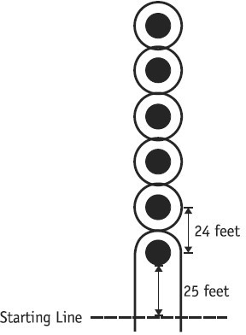

Figure 1: Barrel Bending Race

Figure 8 Barrel Racing
- Three barrels are to be set across the arena in a straight line thirty (30) feet from the timing line. In optimum conditions, the barrels should be set thirty (30) feet apart and should not be closer than twenty (20) feet from the sides of the arena. In small arenas, the barrels may be set closer together, but no closer than twenty (20) feet apart. The barrels should never be more than thirty (30) feet apart.
- The contestant has the option of running the pattern to the left or right as long as they start with the middle barrel.
- Disqualification results if the rider touches the barrel with a hand, running off course & turning a barrel the wrong way.
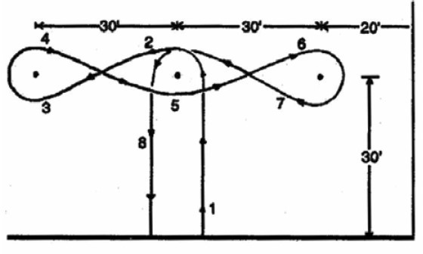

Figure 3: Figure 8 Barrel Race

Flag Race
- The course (see fi g.) is set up in the same manner as for the Cloverleaf Barrel Race. Two 5-gallon buckets filled with approximately 4 inches of sand should be placed on the centers of the 1st and 3rd barrels.
- The length of the flag sticks should be 12 inches to 16 inches above the edge of the bucket. Wooden doweling 3/4 inch in diameter, or other round suitable material, should be used for the flag.
- The rider will pick up a flag at 1, ride behind 2 and place the flag in the bucket at barrel 3. Riders have the option of riding course A or B:
  - Course A – The entry will cross the starting line and begin following the pattern to the left.
  - Course B – The entry will cross the starting line and begin following the pattern to the right.
- Disqualifications – Causes of disqualification include:
  - Failing to pick up the flag on the first pass.
  - Failing to place the flag in the bucket on the first pass.
  - Hitting any part of the horse with the flag or stick.
  - Dropping the flag.
  - Knocking over any of the barrels or knocking the bucket off, or over, on the barrel.
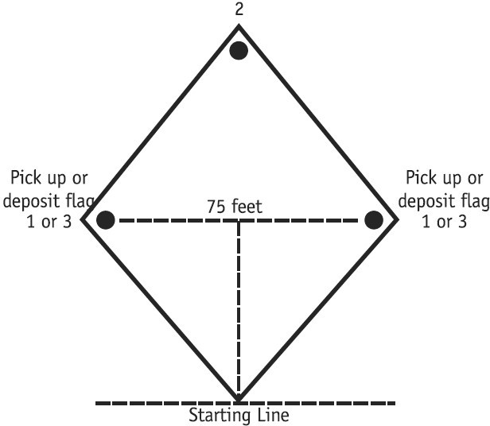
  - Dropping the flag into the bucket with the flag end down.

Figure 4: Flag Race

Go-Go Race
- Four poles are set up six feet apart across the arena and 12 feet apart the length of the arena. The distance from the start and finish line to the first two poles is 40 feet.
- The rider takes the horse/pony through the six-foot lane with all parts of the horse/pony clearing the back pair of poles. The rider then turns around, goes back through the lane and across the finish line.
- Turning before you clear back poles, knocking a pole down, going outside of either or both poles, or holding a pole up will result in disqualification.
- See pattern below.
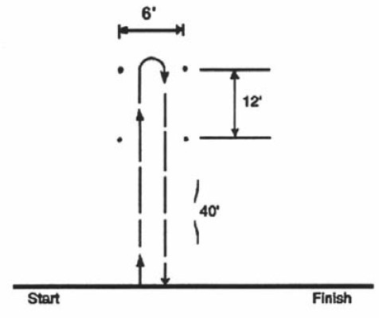
Figure 5: Go-Go Race

Keyhole Race
- The course will be laid out with a limed keyhole on the ground with the opening of the keyhole facing the starting line (see Figure 6 ).
- The center of the circle should be 100 feet from the timing line.
- The keyhole will be in the form of a broken circle 22 feet in diameter with a throat 5 feet wide. The angled sides are 5 feet long.
- The horse will cross the timing line, enter the circle of the keyhole, turn around (in either direction) entirely within the circle of the keyhole, and recross the timing line.
Disqualification – Causes of disqualification include:
- The horse stepping over the chalk line at any point.
- The horse turning around in the throat of the keyhole rather than in the circle.
- Failing to complete the pattern.
- Failing to start or finish between the two markers.

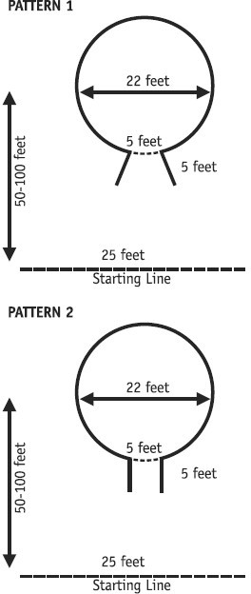
Figure 6: Keyhole Race

Scurry
- There will be three jumps, each 18" high, spaced thirty (30) feet apart, parallel to each other and to the start/finish line. The first jump shall be thirty (30) feet from the start/finish line and the third jump 30 feet from the barrel. Jumps are recommended to be 4"x4" and at least 12 feet long.
- Standards should be such, when possible, that the poles do not roll off on their own.
- Rider will cross starting line, jump all three jumps, then around barrel, again jump all three jumps and cross finish line.
- Rider may run the course to the left or to the right.
- Knockdown of any jump is a two (2) second penalty for each. Knockdown of barrel is a five (5) second penalty.
- Disqualification results from holding up barrel with hand going around jump
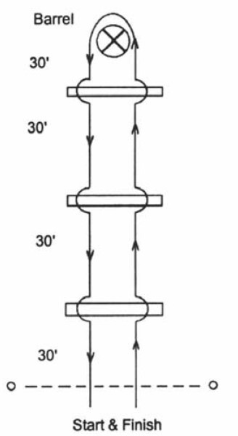

Figure 10: Scurry

Single Pole
- One pole is placed one hundred (100) feet from the starting line, in the center of the arena. Horse crosses starting line on run, rounds pole from either direction and crosses finish line.
- Disqualification results from the rider holding up pole with their hands, or knocking pole down

Stake Race
Figure 11: Single Pole

- The start and finish line is 20 feet wide in the center of the arena and marked by two cones.
- A pole is set 40 feet from the start line toward each end of the arena, so they are set 80 feet apart.
- Start by crossing the start/finish line between the cones, run a figure eight around the upright poles and finish by crossing the start/finish line again and closing the eight.
- At the first pole, the contestant may go left or right, just so the figure eight is run.
- Rider will cross starting line, jump all three jumps, then around barrel, again jump all three jumps and cross finish line.
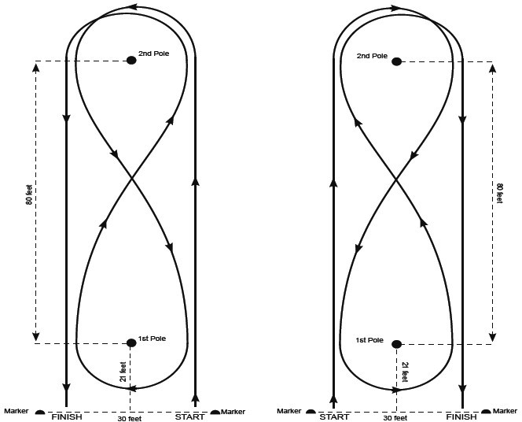
Figure 12: Stake Race

Spur  A timed event. The horse and rider must go through the first set of pylons, make a 360 degree turn around the pole, returning through the second set of pylons. Race may be either a right or left pattern.  Penalties  Only penalties are disqualifications.  Disqualifications  Breaking the pattern. Failure to complete the race, any leg of the horse passing over any cone rather than around the cone, knocking over any cone. Knocking over anything. |  | 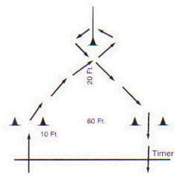

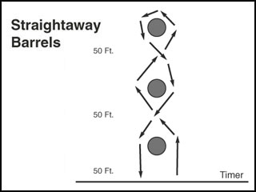 |  | Straight Away Barrels  A timed event. Rider crosses timer line weaving right or left of the barrel, continuing weaving in and out to third barrel, and weave back through to timer line.  Penalties  Five (5) second penalty added for each barrel knocked over.  Disqualifications  Failure to complete pattern. Breaking the pattern.

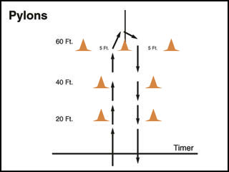 |  | Pylon Alley  A timed event. Rider crosses the timer line between the cones in the first and seconded set, makes a turn around the center cone (of the last three) and returns, going between the cones in the second and first set. A left or right turn may be made around the center cone.  Penalties  Only penalties are disqualifications.  Disqualifications  Breaking the pattern. Failure to complete the race, any leg of the horse passing over any cone rather than around the cone, knocking over any cone.

Bow Tie  A timed event. Rider crosses the timer proceeds to the left of the center cone and than goes right around the right side top and bottom cones, continues to the right of the center cone and around to the left of the left side top and bottom cones and finishes by making a 180 degree turn to the right around the center cone and back across the timer line. Race may begin on the right or left side of the center cone.  Disqualifications  Breaking the pattern, failure to complete the pattern, or straddling a cone plus 5 for all cones. |  | 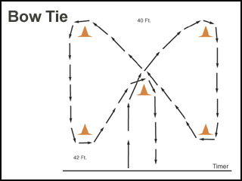

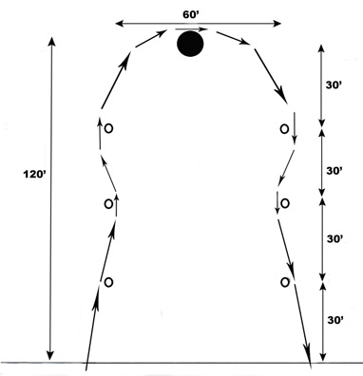 |  | Larryette  This is a timed event. Rider will cross the timer line and goes on the outside of the first pole, inside of second and outside of the third. Going around the barrel rider proceeds to the second set of poles going outside the first, inside the second and outside the third and then runs to cross the timer line. The event can be ran either left or right.  Penalties  A five second penalty will be added to the riders time for each pole or barrel knocked over.  Disqualifications  Failure to complete the race  Breaking the pattern

Hitch & Go  A timed event. Rider crosses timer line going between the first two (2) poles to the next set of poles, either to the right or left pole. Going to the inside of the chosen pole, making a 360 degree turn around the pole, across the arena to the opposite pole and make same (right/left) 360 degree turn, finishing on the inside of the pole. Completing the pattern by going back through the first two (2) poles and across the time line.  Penalties  There will be a five (5) second penalty for knocking over a pole.  Disqualifications  Failure to run a correct/complete pattern will be a disqualification. |  | 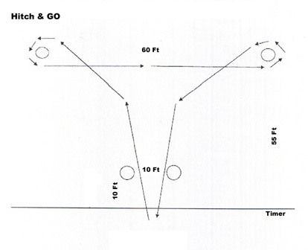

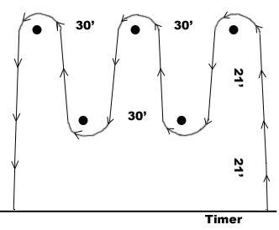 |  | Flying W  A timed event. Rider crosses the timer to the back pole and turns it weaving each pole, turns last pole and returns crossing the timer line. Rider may run either a right or left pattern.  Penalties  Five (5) second penalty added for each pole knocked over.  Disqualifications  Failure to run a correct/complete pattern will be a disqualification.

